
Farmyard
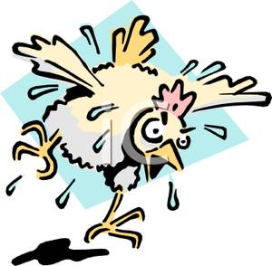
Round ‘Em
Up
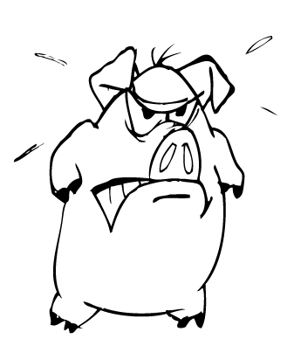



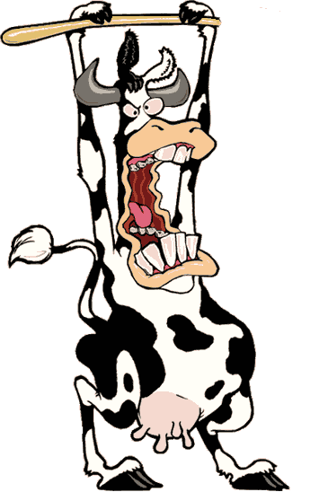

Presented by:
Hanna Bao
Stephen Bidwell
Kevin McDonald
Vincenzo Vitiello
Alexander Watling

Tufts University 203
Game Title:
Farmyard Round ‘Em Up

- Overview

The game takes place on Hoggett Farms, a small ranch in rural New Zealand where three brothers keep chickens, geese, pigs, ducks and cows. They live a simple life on their small piece of land and don’t generally experience much excitement… until one day. The Hoggetts aren’t particularly mean farmers, but they tend to expect a lot of hard work from their livestock, and don’t believe in the concept of a break; now the animals have had enough. After a rousing speech by a particularly surly swine, the perennially perturbed barn-dwellers burst from their home, located on the bank of a river. The Hoggett brothers must catch their livestock before they escape into the wild, never to be seen again. The farm cannot sustain itself if it loses more than 3 animals, so the brothers must be diligent.

- Gameplay

Setting
Rural New Zealand, on a farm.

View
Overhead, 2-Dimensional view.

Input Method
Player controls the Hoggetts using the mouse; moving it up and down will control Wilbur and Zeke, a pair of twins who have taken up guard on the West and East sides of the farm, respectively, and moving the mouse left and right will dictate where Clyde, on the North side, has set himself up.

Difficulty
Animals, based on how well they were treated by the Hoggetts’ and their excitement regarding the breakout, run at varying speeds out of the barn, making some more difficult to catch than the others. The cows, generally treated the best because of their production of milk and fertilizer for the crops, are the slowest as they don’t mind the Hoggetts’ treatment. Next are the pigs, who resent the farmers’ use of them for food and are eager to escape. Finally, the fastest animals are the geese, ducks and chickens, these being the most infuriated over the thievery of their eggs and offspring on a near daily basis; considering their ability to fly, these are the hardest escapees for the player to recover.

- Core Features

Collision Detection
Farmyard Round ‘Em Up utilizes collision detection in that when one of the Hoggett brothers catches something, it removes the caught animal from the screen. To the South is a roaring river which is prone to high waves and strong winds. As a result, the animals avoid going in this direction and would rather risk being caught by the farmers than endangering their lives to the South.

Imaging
Images uploaded into the game will provide the pictures for the following aspects of the game:
- The background: Hoggett Barn, the river, fauna around the farm.
- The animals: a cow, chicken, pig, duck and a goose.
- The farmers: Zeke, Clyde and Wilbur Hoggett.
- The Main and High Score screens.

Scoring
Each animal will be worth a specific number of points which will be added to the player’s total upon his/her catching it. The slower animals are worth less than the faster ones as they are easier to stop from escaping.

Title Screen
This screen will feature a farm-themed image as well as the title of the game.

Sound Effects and Music
The player will enjoy some catchy background music as they attempt to recover the animals running from the barn. Every time an animal escapes from the brothers, they chastise and mock the Hoggetts in their native tongue. For example, “Quack quack!” in this context roughly translates to: “Ha! I’m free from you trio of tyrants. Never again will your cruel hands lay a finger on my child. Goodbye forever!” Of course, this is only a rough translation and each animal will make its own noise with its own intention.

Quit and Pause
Should the player desire, a quit function is implemented into the game, though the developers don’t see a need for any player to want to stop playing.

- Secondary Features

High Score List
The game will keep a tally of the highest scores recorded by players through the history of game

- Game Play State Diagrams

High Level State Diagram for Farmyard Round ‘Em Up

Title
Screen

Main
Game-play
Loop
Increase
Number of
Escapes

Pause is pressed
Pause

Pause is presed
Escape of Number of
an animal escaped <3
Game
Over

Escapes = 3

Low Level State Diagram for Farmyard Round ‘Em Up Main Loop

Shift Wilbur and Zeke

Shift
Clyde
Move Mouse
Up/Down

Move Mouse
Left/Right
Begin Game

Loop to
Increment
Time
Generate
Another
Animal

Disappear
Animal
Wait 1 second
Catch Animal

- Internal Economy

Escaped Animals
As a result of their small-scale farming operation, the Hoggetts don’t enjoy a large profit margin, and since New Zealand eliminated farm subsidies in 1984, the brothers have largely been on their own. Because of this, they can’t afford to lose more than 3 of their animals else their farm will have to close and Zeke, Wilbur and Clyde will have to return to live with their parents, an ignoble lifestyle for men their age.

- Game Balance

Adjusting the Game Difficulty
The game difficulty will not be adjusted because of the random creation of the animals. Since they are so angry, the livestock exit the barn willy-nilly in various directions so that the player cannot expect where the animals will come from next.

- Victory Conditions

Winning the Game
There is no way to actually win the game as the goal is to simply accumulate as many points as possible before 3 of the animals escape.

Losing the Game
The player will lose when they let down the Hoggett brothers by allowing 3 of their animals to escape, forcing them to return home shamefully.

- Interface Design

The following pages include screenshots from Farmyard Round ‘Em Up, including the title, main and High Score screens.
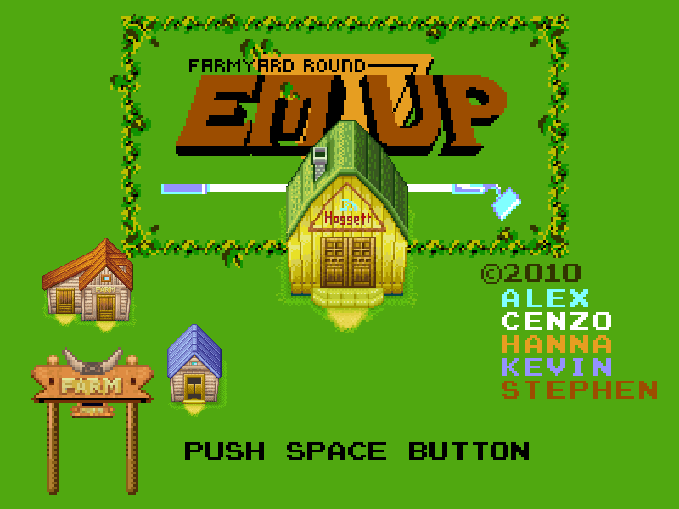
Title Screen

Main Screen
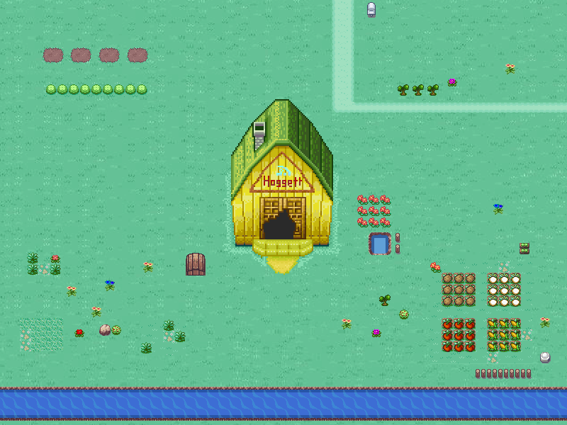

High Score Screen

